1. **INTRODUCTION**

**OVERVIEW OF THE PROJECT**

The project Fitness club management system will be about developing a new website for fitness Club Company to be able to move their business online and increase the availability, affective and efficiency of the business process. In addition, customers can view the products of the company provided with a gallery that has a photo of the fitness club from inside and all the equipment they going to use. The customers can be any company office employees who want to join the fitness club or any.

**1.1 Project modules:**

**Admin:**

Admin can add the details of trainer. He can also add the details of trainers. He can also view update and delete the trainer details. Admin can also add, view, update and delete the equipment details. He can enter the fees details of the club member. Also he can add the menu details for the member. Admin can view the booking details of the user.

**User:**

User can view the trainer, their training timing and book for a particular training timing and book for a particular trainer. He can view all the equipment in the club .Also can view their own fees details and then view the menu chart.

1. **SYSTEM ANALYSIS**

A complete understanding of software requirement is essential to the success of software development effort. No matter how well design/well coded a poorly analyzed and specified program will disappoint the user and bring the grief to the user.

The requirement analysis task is a process of discovery, refinement, modeling and specification. The software initially established by the system engineer and refined during software project, planning is refined in detail. Models of the required information and control flow, operational and data content are created. Alternative solutions are analyzed and allocation to various software elements.

Requirements analysis, software-engineering task that bridge the gap between system level software allocation and software design. Requirements analysis enables to specify software function and performance indicates software’s interface with other system elements and established design constraints that the software must meet. Requirement analysis allows the software engineers to refine.

**2.1 EXISTING SYSTEM:**

Existing system of this project is manual. Therefore lots of human works are needed for a particular operation or processes.

**DISADVANTAGES**

* Not reliable
* The data are stored in different books
* The search operations are not effective
* Time consuming
* Records are kept by hard copy

**2.2 PROPOSED SYSTEM:**

The aim of proposed system is to develop a system of improved facilities .The proposed system can overcome of the limitation of the existing system .The system provides proper security and reduces the manual work. Security of data, ensure data accuracy’s, proper control of the higher officials, minimize manual data entry, better service, minimum time required, user friendliness and interactive, greater efficiency, proper control of higher officials.

**2.3 FEASIBILITY STUDY**

The development of a computer based or product is more likely plagued by resources and difficult delivery data. It is both necessary and prudent to evaluate feasibility of a project at a time, months and years of effort, thousands or millions and untold professional embarrassment can be averted if an inn-convinced system is recognized early in the definition phase.

We proposed our perception of the system, in accordance with the problems of existing system by making a full layout of the system on paper. We tallied the problems and needs by existing system and requirements. We were further updating in the layout in the basis of redefined the problems.

**2.3.1OPERATIONAL FEASIBILITY**

We proposed our perception of the system, in accordance with the problems of existing system by making a full layout of the system on paper. We tallied the problems and needs by existing system and requirements. We were further updating in the layout in the basis of redefined the problems.

In feasibility study phase we had undergone through various steps, which are described as under:

**Cost:** The cost required in the proposed system is comparatively less to the existing system.

**Effort** :Compared to the existing system the proposed system will provide a better working environment in which there will be ease of work and the effort required will be comparatively less than the existing system.

**Time** :Also the time required generating a report or for doing any other work will be comparatively very less than in the existing system. Record finding and updating will take less time than the existing system.

**Labor** :In the existing system the number of staff required for completing the work is more while the new system will require quite less number of staff.

**2.3.2 ECONOMICAL FEASIBILITY**

The proposed system is economically feasible one. We do not want to keep lot of papers for storing the data. By manipulating data using computer reduces cost. We do not want lot of employees; we simply want one to operate it, Administrator.

Economic analysis is most frequently used method for evaluating the effectiveness of a candidate system. More commonly known as cost/benefit analysis, the procedure is to determine the benefits and savings that are expected from a candidate system and compare them with costs.

In my project I make use of the existing systems which have installed on them along PHP with the database which is MYSQL. Though the cost of buying MYSQL is often high, once it is bought, there is no other maintenance cost and we are not buying any other software especially for this project, so we can say that the project is economically feasible.

**2.3.3 TECHNICAL FEASIBILITY**

The project can be said to be technically feasible because there will be less number of errors actually no errors because the whole project will be divided into two modules and so the errors if found, can be debugged very well and all the bugs can be removed. Since the system uses database to implement, it is technically practical for all operators. The system can be implemented on the servers that the department currently has access too. The system requires no special expertise to operate, although some expertise will be required to code it

**3. SYSTEM SPECIFICATION**

**3.1 HARDWARE REQUIRMENTS**

* Processor : Pentium IV or above
* Cache Memory : 512KB
* RAM : 512MB or more
* Hard disk drive : 80GB or more
* Display Type : Color Monitor
* Keyboard : Enhanced 104 Standard
* Mouse : PS/2 2 Button

**3.2 SOFTWARE REQUIRMENTS**

* Operating system : Windows OS.
* Coding Language : PHP,,MySQL

Tools : Dreamweaver

1. **SOFTWARE DESCRIPTION**

**4.1 FRONT END**

**WINDOWS OS**

Microsoft Windows, or simply Windows, is a meta family of [graphical](https://en.wikipedia.org/wiki/Graphical_user_interface) [operating systems](https://en.wikipedia.org/wiki/Operating_system) developed, marketed, and sold by [Microsoft](https://en.wikipedia.org/wiki/Microsoft). It consists of several families of operating systems, each of which cater to a certain sector of the computing industry with the [OS](https://en.wikipedia.org/wiki/Operating_system) typically associated with [IBM PC compatible](https://en.wikipedia.org/wiki/IBM_PC_compatible) architecture. Active Windows families include [Windows NT](https://en.wikipedia.org/wiki/Windows_NT) and [Windows Embedded](https://en.wikipedia.org/wiki/Windows_Embedded); these may encompass subfamilies, e.g. [Windows Embedded Compact](https://en.wikipedia.org/wiki/Windows_Embedded_Compact) (Windows CE) or [Windows Server](https://en.wikipedia.org/wiki/Windows_Server). Defunct Windows families include [Windows 9x](https://en.wikipedia.org/wiki/Windows_9x), [Windows Mobile](https://en.wikipedia.org/wiki/Windows_Mobile) and [Windows Phone](https://en.wikipedia.org/wiki/Windows_Phone).

Microsoft introduced an [operating environment](https://en.wikipedia.org/wiki/Operating_environment) named Windows on November 20, 1985, as a graphical [operating system shell](https://en.wikipedia.org/wiki/Operating_system_shell) for [MS-DOS](https://en.wikipedia.org/wiki/MS-DOS) in response to the growing interest in [graphical user interfaces](https://en.wikipedia.org/wiki/Graphical_user_interface) (GUIs). Microsoft Windows came to [dominate](https://en.wikipedia.org/wiki/Dominance_(economics)) the world's [personal computer](https://en.wikipedia.org/wiki/Personal_computer) (PC) market with [over 90% market share](https://en.wikipedia.org/wiki/Usage_share_of_operating_systems), overtaking [Mac OS](https://en.wikipedia.org/wiki/Classic_Mac_OS), which had been introduced in 1984. [Apple](https://en.wikipedia.org/wiki/Apple_Inc) came to see Windows as an unfair encroachment on their innovation in GUI development as implemented on products such as the [Lisa](https://en.wikipedia.org/wiki/Apple_Lisa) and [Macintosh](https://en.wikipedia.org/wiki/Macintosh) (eventually settled in court in Microsoft's favor in 1993). On PCs, Windows is still the most popular operating system. However, in 2014, Microsoft admitted losing the majority of the overall operating system market to [Android](https://en.wikipedia.org/wiki/Android_(operating_system)), because of the massive growth in sales of Android [Smartphone](https://en.wikipedia.org/wiki/Smartphone). In 2014, the number of Windows devices sold was less than 25% that of Android devices sold. This comparison however may not be fully relevant, as the two operating systems traditionally target different platforms. Still, numbers for server use of Windows (that are comparable to competitors) show one third market share, similar to for end user use.

As of September 2016, the most recent version of Windows for PCs, [tablets](https://en.wikipedia.org/wiki/Tablet_computers), [Smartphone](https://en.wikipedia.org/wiki/Smartphone) and [embedded devices](https://en.wikipedia.org/wiki/Embedded_system) is [Windows 10](https://en.wikipedia.org/wiki/Windows_10). The most recent versions for [server computers](https://en.wikipedia.org/wiki/Server_(computing)) is [Windows Server 2016](https://en.wikipedia.org/wiki/Windows_Server_2016). [A specialized version of Windows](https://en.wikipedia.org/wiki/Xbox_One_system_software) runs on the [Xbox One](https://en.wikipedia.org/wiki/Xbox_One) [video game console](https://en.wikipedia.org/wiki/Video_game_console).

**Server Side Scripting :PHP**

PHP is a server-side scripting language designed primarily for web development but also used as a [general-purpose programming language](https://en.wikipedia.org/wiki/General-purpose_programming_language). Originally created by [Rasmus Lerdorf](https://en.wikipedia.org/wiki/Rasmus_Lerdorf) in 1994, the PHP [reference implementation](https://en.wikipedia.org/wiki/Reference_implementation) is now produced by The PHP Development Team.  PHP originally stood for Personal Home Page, but it now stands for the [recursive acronym](https://en.wikipedia.org/wiki/Recursive_acronym) PHP: Hypertext Preprocessor.

PHP code may be embedded into [HTML](https://en.wikipedia.org/wiki/HTML) or HTML5 [markup](https://en.wikipedia.org/wiki/Markup_language), or it can be used in combination with various [web template systems](https://en.wikipedia.org/wiki/Web_template_system), [web content management systems](https://en.wikipedia.org/wiki/Web_content_management_system) and [web frameworks](https://en.wikipedia.org/wiki/Web_framework). PHP code is usually processed by a PHP [interpreter](https://en.wikipedia.org/wiki/Interpreter_(computing)) implemented as a [module](https://en.wikipedia.org/wiki/Plugin_(computing)) in the web server or as a [Common Gateway Interface](https://en.wikipedia.org/wiki/Common_Gateway_Interface) (CGI) [executable](https://en.wikipedia.org/wiki/Executable). The [web server](https://en.wikipedia.org/wiki/Web_server) software combines the results of the interpreted and executed PHP code, which may be any type of data, including images, with the generated [web page](https://en.wikipedia.org/wiki/Web_page). PHP code may also be executed with a [command-line interface](https://en.wikipedia.org/wiki/Command-line_interface) (CLI) and can be used to implement [standalone](https://en.wikipedia.org/wiki/Computer_software) [graphical applications](https://en.wikipedia.org/wiki/Graphical_user_interface).

The standard PHP interpreter, powered by the [Zend Engine](https://en.wikipedia.org/wiki/Zend_Engine), is [free software](https://en.wikipedia.org/wiki/Free_software) released under the [PHP License](https://en.wikipedia.org/wiki/PHP_License). PHP has been widely ported and can be deployed on most web servers on almost every [operating system](https://en.wikipedia.org/wiki/Operating_system) and [platform](https://en.wikipedia.org/wiki/Computing_platform), free of charge.

The PHP language evolved without a written [formal specification](https://en.wikipedia.org/wiki/Formal_specification) or standard until 2014, leaving the canonical PHP interpreter as a [de facto](https://en.wikipedia.org/wiki/De_facto) standard. Since 2014 work has gone on to create a formal PHP specification.

### PHP 5

On July 13, 2004, PHP 5 was released, powered by the new Zend Engine II PHP 5 included new features such as improved support for [object-oriented programming](https://en.wikipedia.org/wiki/Object-oriented_programming), the PHP Data Objects (PDO) extension (which defines a lightweight and consistent interface for accessing databases), and numerous performance enhancements. In 2008 PHP 5 became the only stable version under development. [Late static binding](https://en.wikipedia.org/wiki/Late_static_binding) had been missing from PHP and was added in version 5.3.

Many high-profile open-source projects ceased to support PHP 4 in new code as of February 5, 2008, because of the GoPHP5 initiative,  provided by a consortium of PHP developers promoting the transition from PHP 4 to PHP 5.

Over time, PHP interpreters became available on most existing [32-bit](https://en.wikipedia.org/wiki/32-bit) and [64-bit](https://en.wikipedia.org/wiki/64-bit) operating systems, either by building them from the PHP source code, or by using pre-built binaries. For the PHP versions 5.3 and 5.4, the only available [Microsoft Windows](https://en.wikipedia.org/wiki/Microsoft_Windows) binary distributions were 32-bit [x86](https://en.wikipedia.org/wiki/X86) builds, requiring Windows 32-bit compatibility mode while using [Internet Information Services](https://en.wikipedia.org/wiki/Internet_Information_Services) (IIS) on a 64-bit Windows platform. PHP version 5.5 made the 64-bit [x86-64](https://en.wikipedia.org/wiki/X86-64) builds available for Microsoft Windows.

### PHP 6 and Unicode

PHP has received criticism due to lacking native [Unicode](https://en.wikipedia.org/wiki/Unicode) support at the core language level, instead only supporting byte strings. In 2005, a project headed by Andrei Zmievski was initiated to bring native Unicode support throughout PHP, by embedding the [International Components for Unicode](https://en.wikipedia.org/wiki/International_Components_for_Unicode) (ICU) library, and representing text strings as [UTF-16](https://en.wikipedia.org/wiki/UTF-16) internally. Since this would cause major changes both to the internals of the language and to user code, it was planned to release this as version 6.0 of the language, along with other major features then in development.

However, a shortage of developers who understood the necessary changes, and performance problems arising from conversion to and from UTF-16, which is rarely used in a web context, led to delays in the project. As a result, a PHP 5.3 release was created in 2009, with many non-Unicode features back-ported from PHP 6, notably namespaces. In March 2010, the project in its current form was officially abandoned, and a PHP 5.4 release was prepared containing most remaining non-Unicode features from PHP 6, such as traits and closure re-binding. Initial hopes were that a new plan would be formed for Unicode integration, but as of 2014 none had been adopted.

### PHP 7

During 2014 and 2015, a new major PHP version was developed, which was numbered PHP 7. The numbering of this version involved some debate. While the PHP 6 Unicode experiment had never been released, several articles and book titles referenced the PHP 6 name, which might have caused confusion if a new release were to reuse the name. After a vote, the name PHP 7 was chosen.

The foundation of PHP 7 is a PHP [branch](https://en.wikipedia.org/wiki/Branching_(revision_control)) that was originally dubbed PHP next generation (phpng). It was authored by Dmitry Stogov, Xinchen Hui and Nikita Popov, andaimed to optimize PHP performance by refactoring the Zend Engine to use more compact [data structures](https://en.wikipedia.org/wiki/Data_structures) with improved [cache locality](https://en.wikipedia.org/wiki/Locality_of_reference) while retaining near-complete language compatibility As of 14 July 2014, [WordPress](https://en.wikipedia.org/wiki/WordPress)- based benchmarks, which served as the main benchmark suite for the phpng project, showed an almost 100% increase in performance. Changes from phpng are also expected to make it easier to improve performance in the future, as more compact data structures and other changes are seen as better suited for a successful migration to a [just-in-time](https://en.wikipedia.org/wiki/Just-in-time_compilation) (JIT) compiler. Because of the significant changes, the reworked Zend Engine is called Zend Engine 3, succeeding Zend Engine 2 used in PHP 5.

Because of major internal changes in phpng, it must receive a new [major version](https://en.wikipedia.org/wiki/Software_versioning) number of PHP, rather than a minor PHP 5 release, according to PHP's release process. Major versions of PHP are allowed to break backward-compatibility of code and therefore PHP 7 presented an opportunity for other improvements beyond phpng that require backward-compatibility breaks, including wider use of [exceptions](https://en.wikipedia.org/wiki/Exception_(computer_science)), reworking variable syntax to be more consistent and complete, and the deprecation or removal of various legacy features.

PHP 7 also introduced new language features, including return type declarations for functions,  which complement the existing parameter type declarations, and support for the scalar types (integer, float, string, and Boolean ) in parameter and return type declarations.

**Client Side Script: HTML,JQuery, Ajax,JavaScript.**

**jQuery**

jQuery is not a language, but it is a well written JavaScript code. As quoted on official jQuery website, "it is a fast and concise JavaScript Library that simplifies HTML document traversing, event handling, animating, and Ajax interactions for rapid web development". jQuery is not a language, but it is a well written JavaScript code. As quoted on official jQuery website, "it is a fast and concise JavaScript Library that simplifies HTML document traversing, event handling, animating, and Ajax interactions for rapid web development." In order to work with jQuery, you should be aware of the basics of JavaScript, HTML and CSS. It was released in January 2006 at BarCamp NYC by John Resig. jQuery is very compact and well written JavaScript code that increases the productivity of the developer by enabling them to achieve critical UI functionality by writing very small amount of code.

* It helps to improve the performance of the application
* It helps to develop most browser compatible web page
* It helps to implement UI related critical functionality without writing hundreds of lines of codes
* It is fast
* It is extensible – jQuery can be extended to implement customized behavior

Other advantages of jQuery are:

* No need to learn fresh new syntaxes to use jQuery, knowing simple JavaScript syntax is enough
* Simple and cleaner code, no need to write several lines of codes to achieve complex functionality

**JavaScript**

JavaScript is a programming language that allows you to implement complex things on web pages — every time a web page does more than just sit there and display static information for you to look at — displaying timely content updates, or interactive maps, or animated 2D/3D graphics, or scrolling video jukeboxes, etc. — you can bet that JavaScript is probably involved. It is the third layer of the layer cake of standard web technologies, two of which ([HTML](https://developer.mozilla.org/en-US/docs/Learn/HTML) and [CSS](https://developer.mozilla.org/en-US/docs/Learn/CSS)) we have covered in much more detail in other parts of the Learning Area.

* [HTML](https://developer.mozilla.org/en-US/docs/Glossary/HTML) is the markup language that we use to structure and give meaning to our web content, for example defining paragraphs, headings, and data tables, or embedding images and videos in the page.
* [CSS](https://developer.mozilla.org/en-US/docs/Glossary/CSS) is a language of style rules that we use to apply styling to our HTML content, for example setting background colors and fonts, and laying out our content in multiple columns.
* [JavaScript](https://developer.mozilla.org/en-US/docs/Glossary/JavaScript) is a programming language that enables you to create dynamically updating content, control multimedia, animate images, and pretty much everything else. (Okay, not everything, but it is amazing what you can achieve with a few lines of JavaScript code.)

**HTML**

HTML is a computer language devised to allow website creation. These websites can then be viewed by anyone else connected to the Internet. It is relatively easy to learn, with the basics being accessible to most people in one sitting; and quite powerful in what it allows you to create. It is constantly undergoing revision and evolution to meet the demands and requirements of the growing Internet audience under the direction of the [» W3C](http://www.w3.org/), the organisation charged with designing and maintaining the language.

The definition of HTML is HyperText Markup Language.

* HyperText is the method by which you move around on the web — by clicking on special text called hyperlinks which bring you to the next page. The fact that it is hyper just means it is not linear — i.e. you can go to any place on the Internet whenever you want by clicking on links — there is no set order to do things in.
* Markup is what HTML tags do to the text inside them. They mark it as a certain type of text (italicised text, for example).
* HTML is a Language, as it has code-words and syntax like any other language.

HTML consists of a series of short codes typed into a text-file by the site author — these are the tags. The text is then saved as a html file, and viewed through a [browser](http://www.yourhtmlsource.com/starthere/glossary.html#browser), like Internet Explorer or Netscape Navigator. This browser reads the file and translates the text into a visible form, hopefully rendering the page as the author had intended. Writing your own HTML entails using tags correctly to create your vision. You can use anything from a rudimentary text-editor to a powerful graphical editor to create HTML pages.

**4.2 BACK END**

**WAMPSERVER**

**Introduction**

WAMP is a Windows OS based program that installs and configures Apache web server, MySQL database server, PHP scripting language, phpMyAdmin (to manage MySQL database’s), and SQLiteManager (to manage SQLite database’s). WAMP is designed to offer an easy way to install Apache, PHP and MySQL package with an easy to use installation program instead of having to install and configure everything yourself. WAMP is so easy because once it is installed it is ready to go. You don’t have to do any additional configuring or tweaking of any configuration files to get it running.  There are usually two reasons why someone chooses to install WAMP. They are looking to install WAMP for development purposes or to run their own server.

**Wamp Server Contains**

**1-PHP Admin**

Allows you to change or add users and for making new databases phpMyAdmin is a free software tool written in [PHP](http://php.net/), intended to handle the administration of [MySQL](http://mysql.com/) over the World Wide Web. PhpMyAdmin supports a wide range of operations with MySQL. The most frequently used operations are supported by the user interface (managing databases, tables, fields, relations, indexes, users, permissions, etc), while you still have the ability to directly execute any SQL statement.

**Features**

* Intuitive web interface
* Support for most MySQL features:
* browse and drop databases, tables, views, fields and indexes
* create, copy, drop, rename and alter databases, tables, fields and indexes
* maintenance server, databases and tables, with proposals on server configuration
* execute, edit and bookmark any SQL-statement, even batch-queries
* manage MySQL users and privileges
* manage stored procedures and triggers
* Import data from CSV and SQL
* Export data to various formats: CSV, SQL, XML, PDF, ISO/IEC 26300 – Open Document Text and Spreadsheet, Word, LATEX and others
* Administering multiple servers
* Creating PDF graphics of your database layout
* Creating complex queries using Query-by-example (QBE)
* Searching globally in a database or a subset of it
* Transforming stored data into any format using a set of predefined functions, like displaying BLOB-data as image or download-link

MY SQL

MySQL exceeds dependability requirements and provides innovative capabilities that increase employee effectiveness, integrate heterogeneous IT ecosystems, and maximize capital and operating budgets. MySQL provides the enterprise data management platform the organization needs to adapt quickly in a fast-changing environment. With the lowest implementation and maintenance costs in the industry, MySQL delivers rapid return on data management investment. It supports the rapid development of enterprise-class business applications that can give an insurance company a critical competitive advantage. Benchmarked for scalability, speed, and performance, it is a fully enterprise-class database product, providing core support for Extensible Markup Language (XML) and Internet queries.

1. **PROJECT DESCRIPTION**

**5.1 PROBLEM DEFINITION**

The existing system is a manual. In the present system, all the activities are done manually. All data entry is performed by writing data into the book, paper documents. The records are prepared manually, so there is a chance for occurring errors and the calculations are not so accurate. When there is need for retrieving details searching is unavoidable, this is a difficult task searching the records manually.

**5.2DATAFLOW DIAGRAM**

A DFD is a graphical representation that depicts information flow and the transforms that are applied as data move from input to output. The basic form of a DFD is also known as a Data flow graph or a bubble chart.

DFD may be used to represent a system or software at any level of abstraction. DFDs can be partitioned into levels that represent increasing information flow and functional detail. A level 0 DFD, also called a fundamental system model or a context model, represents the entire software element or a single bubble with input and output data indicated by incoming and outgoing arrows, respectively. A level 1 DFD may contain five or six bubbles with interconnection arrows. Each of the processes represented at level 1 is a sub function of the overall system depicted in the context model.

**DFD Notations**

* It represents a process or transform that is applied to data.

It represents data store-stored information that is used by software

* It represents a source or destination

It represents a flow of data, that is, a data stream.

As illustrated in the above figure, the circle and or the bubble represent the transformation process, and the label inside the bubble describes the process, using an active verb to do so. Data flows or directed lines that identify the input data flows and output data flows at each process bubble. Data storage represented by an open-ended rectangle with a label that identifies the data store or file. The square is labeled to identify an external entity that is source or destination of a data flow.

Context level-0

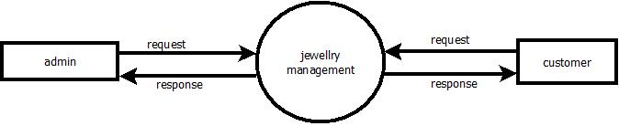

Level 1

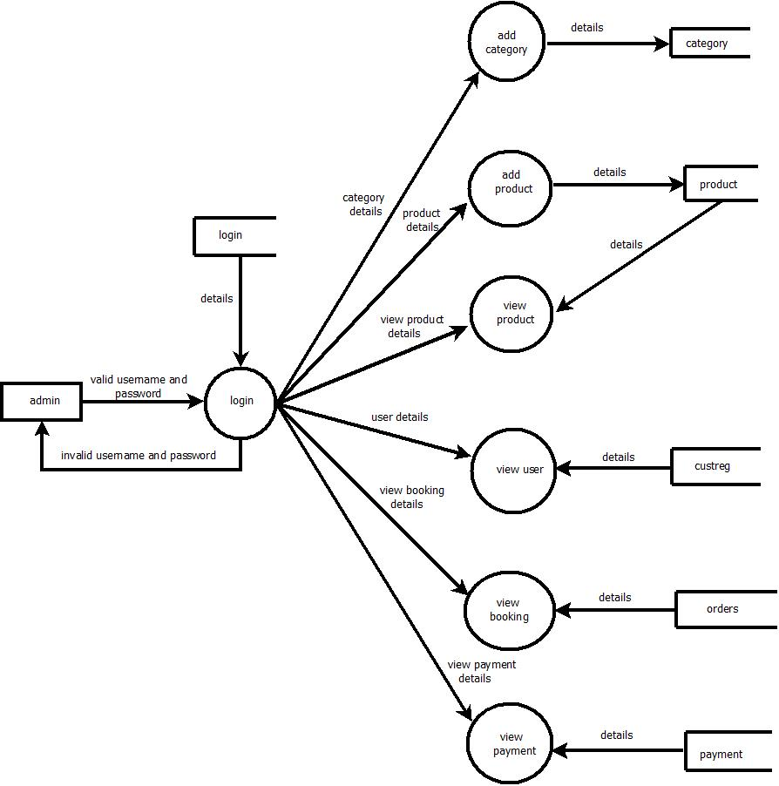

LEVEL 2

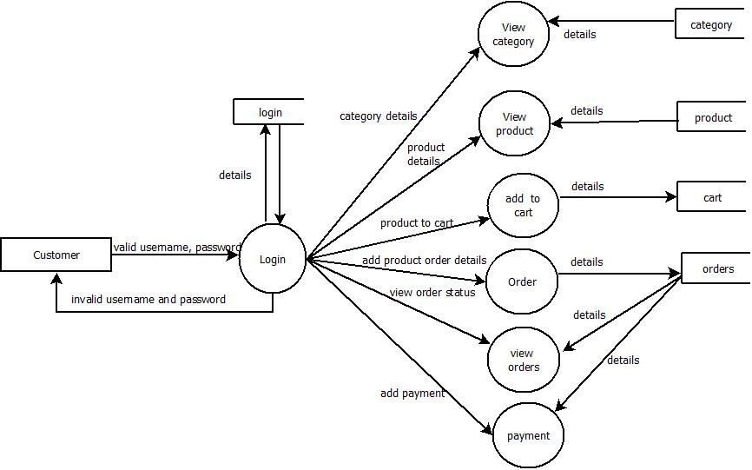

**5.3DATABASE DESIGN**

A database is a collection of interrelated data stored within minimum redundancy to serve many users quickly and efficiently. It is a process of designing the database file, which is the key source of the information in the system. The objective of database is to design is to provide storage and it contributes to the overall efficiency of the system. The file should properly design and planned for collection, accumulation, editing and retrieving the required information.

The primary objective of a database design is fast response time to inquiries, more information at low cost, control of redundancy, clarity and ease of use, accuracy and integrity of the system, fast recovery and availability of powerful end-user languages. The theme behind a database is to handle information as an integrated whole thus the main objective is to make information as access easy, quick, inexpensive and flexible for the users. In this project, we mainly concentrated into relational databases.

Relational database stores data in tables, which is turn, are composed of rows also known as records, columns also known as fields. The fields in the relational model are: -

**Primary Key**

The key which is uniquely identify records. They also notify the not null constraints

1. Table Name: Registration

Description: This table is used to store the user details.

|  |  |  |  |
| --- | --- | --- | --- |
| Field name | Datatype | Constraints | Description |
| Rid | Integer | Primary key | Registration id |
| Name | Varchar | Not null | Name |
| Addr | Varchar | Not null | Address |
| Phno | Varchar | Not null | Phone no |
| Email | Varchar | Not null | Email |

1. Table Name: Login

Description: This table is used to store the login details.

|  |  |  |  |
| --- | --- | --- | --- |
| Field name | Datatype | Constraints | Description |
| Uid | Integer | Foreign key | User id |
| Email | Varchar | Not null | Email id |
| Upass | Varchar | Not null | Password |
| Utype | Varchar | Not null | User type |

1. Table Name: Trainer

Description: This table is used to store the trainer details.

|  |  |  |  |
| --- | --- | --- | --- |
| Field name | Datatype | Constraints | Description |
| Tid | Integer | Primary key | Trainer id |
| Tname | Varchar | Not null | Trainer name |
| Phno | Varchar | Not null | Phone no |
| Email | Varchar | Not null | Email id |
| Title | Varchar | Not null | Title |
| Exp | Varchar | Not null | Experience |
| Tm | Varchar | Not null | Time |
| Img | Varchar | Not null | Image |

1. Table Name :Equipment

Description: This table is used to store the equipment details.

|  |  |  |  |
| --- | --- | --- | --- |
| Field name | Datatype | Constraints | Description |
| Eid | Int | Primary key | Equipment id |
| Ename | Varchar | Not null | Equipment name |
| Wgt | Varchar | Not null | Weight |
| Qty | Varchar | Not null | Quantity |
| Ucost | Varchar | Not null | Unit cost |
| Uf | Varchar | Not null | Used for |
| Img | Varchar | Not null | Image |

1. Table Name :Fees

Description: This table is used to store the Fees details.

|  |  |  |  |
| --- | --- | --- | --- |
| Field name | Datatype | Constraints | Description |
| Fid | Integer | Primary key | Fees id |
| Mid | Integer | Foreign key | Member id |
| Mname | Varchar | Not null | Member name |
| Dat | Varchar | Not null | Date |
| Amt | Varchar | Not null | Amount |

1. Table Name: Food

Description: This table is used to store trainer details.

|  |  |  |  |
| --- | --- | --- | --- |
| Field name | Datatype | Constraints | Description |
| Ffid | Integer | Primary key | Food id |
| Bname | Varchar | Not null | Breakfast name |
| Lunch | Varchar | Not null | Lunch name |
| Dinner | Varchar | Not null | Dinner name |
| Oth | Varchar | Not null | Other |

1. Table Name: Booking

Description: This table is used to store the booking details.

|  |  |  |  |
| --- | --- | --- | --- |
| Field name | Datatype | Constraints | Description |
| Bkid | Int | Primary key | Booking id |
| Vid | Varchar | Foreign key | Visitor id |
| Tid | Varchar | Not null | Trainer id |
| Tname | Varchar | Not null | Trainer name |
| Tm | Varchar | Not null | Time |
| Status | Varchar | Not null | Status |

**5.4 SYSTEM DESIGN**

System designing is the process of defining the architecture, components, modules, interfaces and data for a system to satisfy specified requirements. It is a solution to a “how to” approach compared to system analysis which is a “what is” orientation. It translates the system requirements into ways of making them operational. The design phase focuses on the detailed implementation of the system recommended in the feasibility study.

The system which is in making is developed by working on two different modules and combining them to work as a single unit. That single unit is the one which is known as the new software. We go through the different design strategies to design the system we are talking about. In the input design we decide which type of input screens are going to be used for the system in making. In the output design we decide the output screens and the reports that will be used to give the output and in the database design we decide what all tables will be required and what all fields will be there in those tables. Each of them is discussed briefly below.

Simple designs are easily understood, easily built, and easily tested. Simplicity is the most important criteria of a design. Other design criteria include the following.

**Documentation**: A good design always comes with a set of well-written documents. Proper documentations are done throughout this project.

**Testability**: In a good design every requirement is testable. A design that cannot be easily tested against its requirements is not acceptable design. This system is testable and the bugs can be reported easily.

**Structure**: A good design presents hierarchical structure that makes logical use of control policies among components.

**Modularity**: a good design is modular and exhibits the properties of high cohesiveness and low coupling.

**Discreteness**: A good design separates data procedures and timing consideration to the extent possible.

**Representation**: A good design should be easily communicated to all interested parties through appropriate abstraction and representation.

**Reusability**: A good design should be repeatable and reusable.

Various Design Concepts

There are various fundamental design concepts, which are designed for a perfect system. These include: -

**1. Process design**: The design phase focuses on the detailed implementation of the system recommended in the feasibility study. Emphasis is on the translating performance specification.

2. Conceptual Design: After the study and the analysis of the existing system the functional and operational requirements were identified. Based on these requirements the conceptual model of the system is designed.

**3. Logical Design**: The logical design reviews the present system and prepares input and output specifications, editing, security and control specification, details of the implementation plans a logical design walk through.

**4. Physical Design**: The physical design maps out the details of the physical system plans. The system implementation derives a test and implementation plan and specifies any new hardware and software.

**5. Input Design**: The input design is the process of converting user-oriented inputs into computer-based formats. It also includes determining the recording media method of input, speed of capture and entry into the system.

**6. Output Design**: The normal procedure is to design the output in detail first and then to work back to the input forms. The output can be in the form of operational documents or lengthy reports. The input records have to be validated edited and organized and finally accepted by the system before being processed to produce the output.

**7. Database Design**: The database is a collection of interrelated data stored within a minimum of redundancy to serve many applications. It minimizes the artificiality embedded in using separate files. The primary objectives are fast response time to enquiries, more information at low cost, redundancy control, clarity and ease of use, accuracy and fast recovery.

**8. Code Design**: The process of coding is to facilitate the identification and retrieval of items of information. The code should be simple and easily understandable. The codes were designed in such a manner that features such as optimum human oriented use and machine efficiency are unaffected. The code should be adequate for present and anticipated data

**5.5 NORMALIZATION**

After the conceptual level, the next level of process of database design to organize the database structure into a good shape called Normalization. The normalization simplifies the entries, removing redundancies from the system data and finally builds a data structure, which is both flexible and adaptable to the system. The different normal forms obtained during the database design are given below:

In the database design, we create a database with different tables that is used to store the data. We normalize the data in the table. **Database normalization** is the process of organizing the fields and tables in a relational database to minimize redundancy and dependency. Normalization usually involves dividing large tables into smaller (and less redundant) tables and defining relationships between them. The objective is to isolate data so that additions, deletions, and modifications of a field can be made in just one table and then propagated through the rest of the database via the defined relationships. In the project I have made used of the 3rd normal form, Third Normal Form (3NF) is a property of database tables. A relation is in third normal form if it is in Second Normal Form and there are no functional (transitive) dependencies between two (or more) non-primary key attributes. The overall objective in the development of database technology has been to treat data as an organizational resource and as an integrated whole. Database Management System allows data to be protected and organized separately from other resources. Database is an integrated collection of data. This is the difference between logical and physical data.

In my project, I have made use of tables which are stored in the database named **Fitness Club Management System**. The tables are used to store the values that are generated by the application. The main field names and the key constraints of all the tables are shown below in detail.

1. **SYSTEM TESTING**

**Fitness Club Management System** was tested and found to be working as expected. There was no abnormal behavior reported during the testing of the program. Testing is a method by which we try reducing the testing efforts and bringing out the maximum output. Testing helps us in knowing whether the logical assumptions that we have taken for the system are correct, and if they are correct we have obtained our goal. We test the system to know the errors, to check the validity of the information, to also group the modules with the aim that we meet the system requirements according to the system needs.

Testing is vital to the success of the system. System testing makes logical assumption that if all the parts of the system are correct, we have achieved the mission successfully. System testing is the stage of implementation that is aimed at assuring that the system works accurately and efficiently before the live operation commences.

**6.1 UNIT TESTING**

The Fitness Club Management System was divided into several units and tested individually. Each unit was found to be working satisfactorily. This testing is carried out during the programming stage itself. In this testing step each module is found to be working satisfactorily as regards to the expected output from the module. Using a method called white box testing in which the software tester has knowledge of the inner workings, structure and language of the software, or at least its purpose and where each module or component of the software is tested individually. In the unit test case we will be testing the separate modules of the Software. We will test the components by passing data through it and we will be monitoring data to find the errors. We will be looking for entry and exit conditions of the data. We will make sure that all the components work without any troubles.

**6.2 INTEGRATION TESTING**

After splitting the program into units, the units were tested together to see the defects between each module and function. It is testing two or more modules or functions together with the intent of finding interface defects between the modules or functions. Testing completed at as part of unit or functional testing, and sometimes, becomes its own standalone test phase. On a larger level, integration testing can involve putting together of groups of modules and functions with the goal of completing and verifying that the system meets the system requirements.

**6.3 USERACCEPTANCE TESTING:**

User acceptance of a system is the key factor for the success of any system. The system under considerations is tested for user acceptance by constantly keeping in touch with the prospective system users at the time of developing and making of hardware management system software. In this project the acceptance test is done and satisfied by the user by meting his requirements

* 1. **SYSTEM IMPLEMENTATION**

**7.1 INTRODUCTION**

Implementation is an activity that is contained throughout the development phase. It is the process of bringing a developed system into operational use and turning it over to the user. The new system and its components are to be tested in a structured and planned manner. A successful system should be delivered and users should have the confidence that the system would work efficiently and effectively. The more complex the system being implemented the more involved will be the system analysis and design effort required for implementation. Implementation is the stage of the system when the theoretical design is turned into working system. The implementation involves careful planning investigation of the current system and its constraints on implementing, design of methods to achieve the changeover, training of user over procedure and evaluation change over method. There are three types of implementation:

Maintenance corresponds to restoring something to original conditions, covering a wide range of activities including correcting codes and design errors and updating user support. Maintenance is performed most often to improve the existing software rather than to a crisis or risk failure. The system would fail if not properly maintained. The software maintenance is an important one in the software development because we have to spend more efforts for maintenance. Software maintenance is to improve the software quality according to the requirements. After a system is successfully implemented, it should be maintained in a proper manner. The need for system maintenance is to make the system adaptable to the changes in the system environment. There may be social, economical or technical changes, which affect system being implemented.

**7.2 SYSTEM MAINTAINENCE**

Maintenance corresponds to restoring something to original conditions, covering a wide range of activities including correcting codes and design errors and updating user support. Maintenance is performed most often to improve the existing software rather than to a crisis or risk failure. The system would fail if not properly maintained. The software maintenance is an important one in the software development because we have to spend more efforts for maintenance. Software maintenance is to improve the software quality according to the requirements. After a system is successfully implemented, it should be maintained in a proper manner. The need for system maintenance is to make the system adaptable to the changes in the system environment. There may be social, economical or technical changes, which affect system being implemented. Software product enhancements may involve providing new functional capabilities, improving user displays and mode of interaction, upgrading the performance characteristics of the system. So only through proper system maintenance procedures, the system can be adapted to cope with these changes. We may define maintenance by describing four activities that are undertaken to after a program is released for use. The first maintenance activity occurs because it is unreasonable to assume that software testing will uncover all latent errors in a large software system. During the use of any large program, errors will occur and be reported to the developer. The process that includes the diagnosis and correction of one or more errors is called corrective maintenance. The second activity that contributes to a definition of maintenance occurs because of the rapid change that is encountered in every aspects of computing. Therefore, adaptive maintenance – an activity that modifies software to properly interface with a changing environment is both necessary and common place. The third activity that may be applied to a definition of maintenance occurs when a software package is successful. As the software is used, recommendations for new capabilities, modifications to existing functions, and general enhancements are received from users. To satisfy requests in this category, perfective maintenance is performed. This activity accounts for the majority of all efforts expended on software maintenance.

The fourth maintenance activity occurs when software is changed to improve future maintainability or reliability, or to provide a better basis for future enhancements. Often called preventive maintenance, this activity is characterized by reverse engineering and re-engineering techniques.

* 1. **CONCLUSION & FUTURE ENHANCEMENT**

**8.1 CONCLUSION**

The project **“Fitness Club Management System”** was successfully designed and developed as

per the requirements and specification .It is concluded that application works well . It allows the

user to store the trainer details, the details of person who is in the gym, equipment

details etc. This software package allows storing the details of all the data related to

fitness club. The system is strong enough to withstand mbnm` regressive yearly operations under

conditions where the database is maintained and cleared over a certain time of span. The

implementation of the system in the organization will considerably reduce.The application is

tested very well and errors are properly debugged .This system is user friendly so everyone can

use easily Proper documentation is provided .The end user can easily understand how the whole

system is implemented by going through the documentation.The system is tested implemented

and the performance is found to implemented and the performance is found to be satisfactory .All

necessary output is generated. Thus, the project is completed successfully.

**8.2 FUTURE ENHANCEMENT**

Any system which has been in use for a number of years gradually decays and become less effective because of change in environment to which it has to be adapted. For the time being it is possible to overcome problems by amendments and minor modifications to acknowledge the need of fundamental changes.

Nothing is perfect; in future we would like our prototype to be more perfect by including future improvements. The proposed system is very easy to handle so everyone can access.

* The entire process of the firm can be computerized.
* More number of item details can be inserted into the database.
* It can be integrated with the web for universal access.
* Upgrading the performance .This system is now implemented at the client machine only but as a future enhancement we can modify the system in such a way to make it work on a client- server network. The system can be even more enhanced by making it an internet based system.
* The efficiency of the developed system can be improved by modification. Today most of the services are based on web services. This system can also be connected online.

**9 SCREEN SHORT**

**Home Page**



**Login**

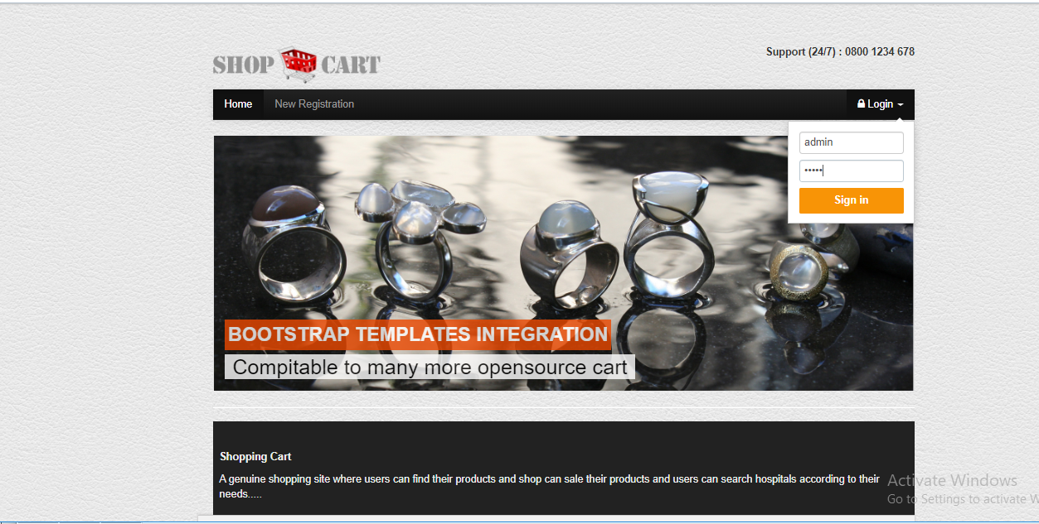

**Admin Home**

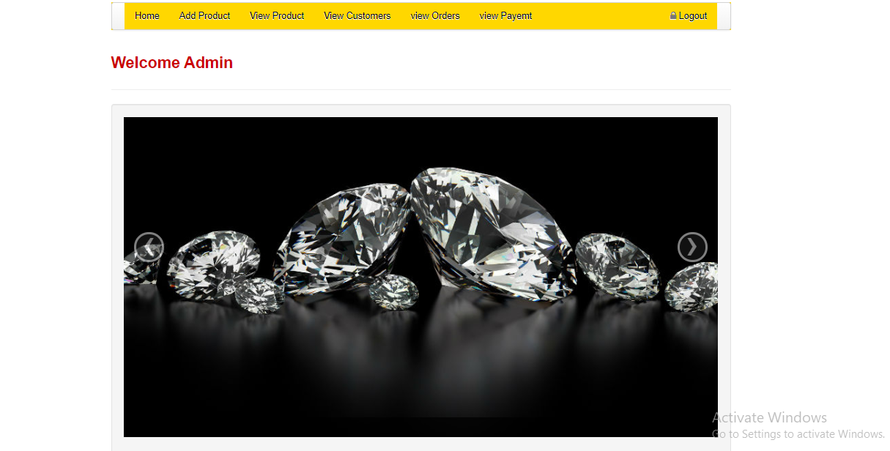

**View Orders**

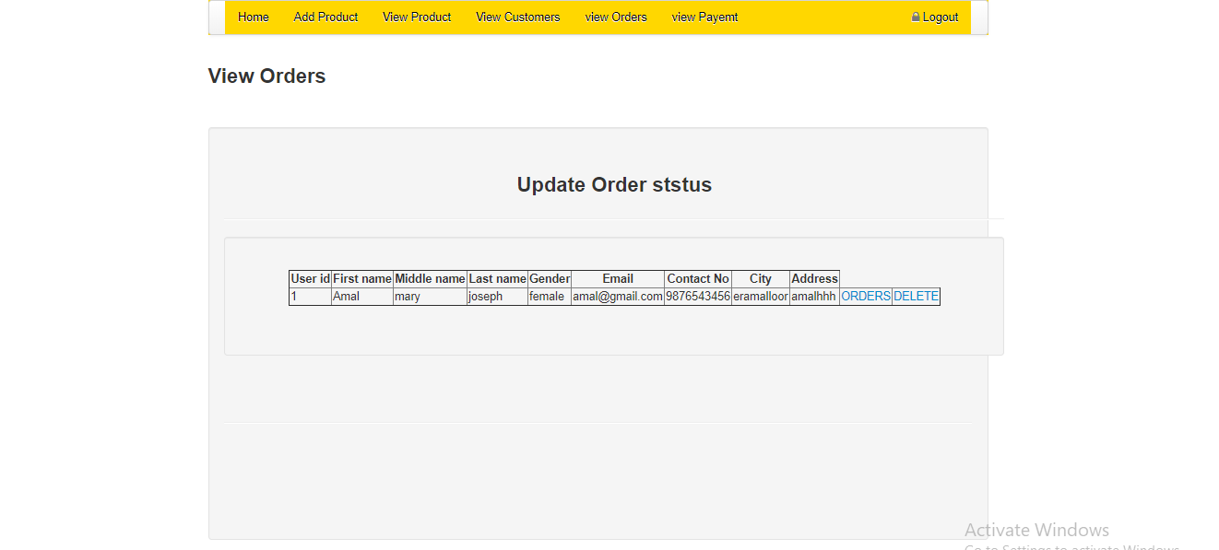

**User Home+**

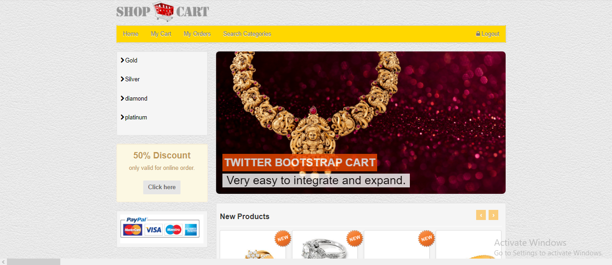

**View Products**

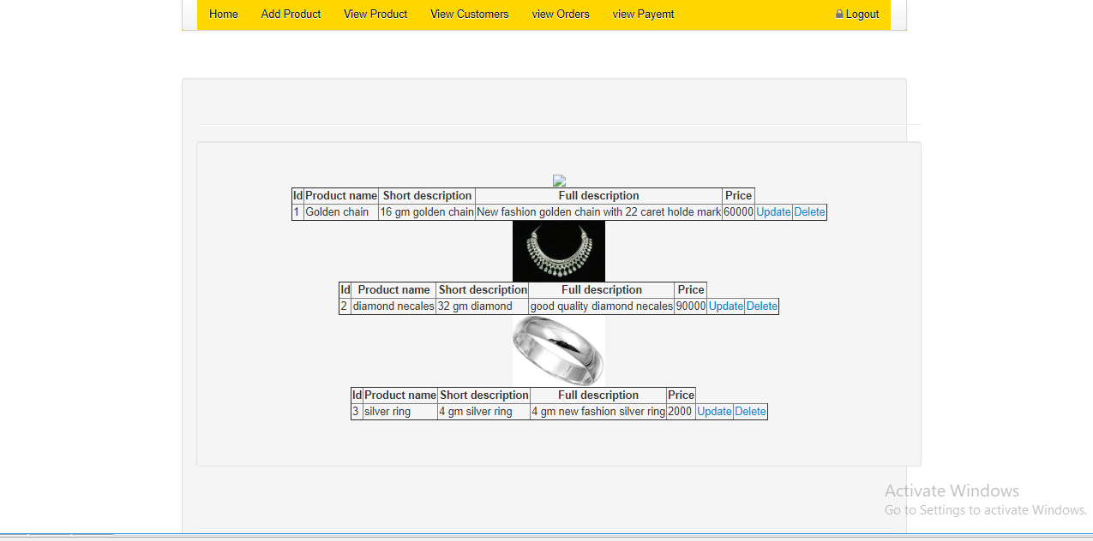

**Order Status**

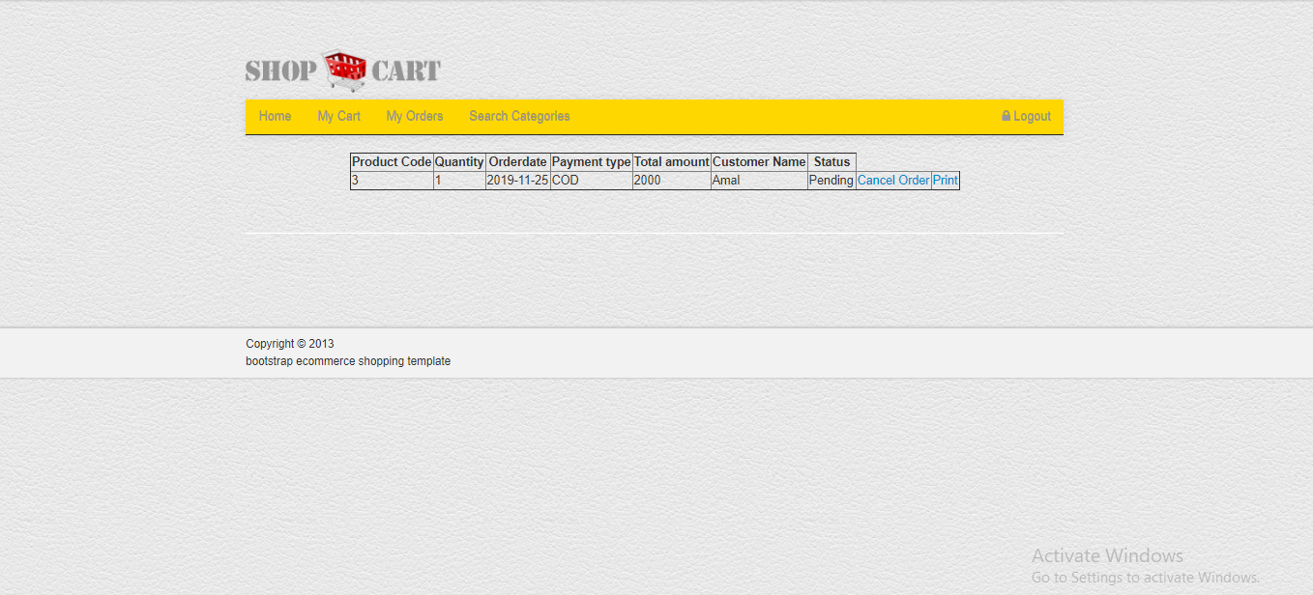

**Search Category**

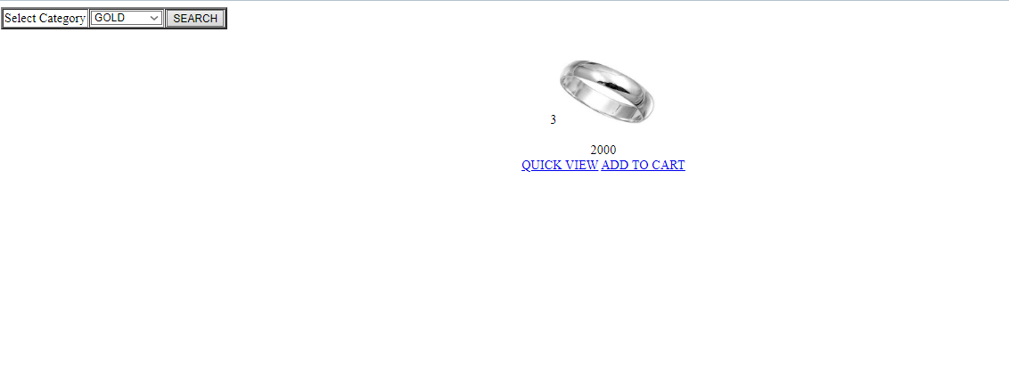

**10 REPORTS**

**CATEGORY DETAILS**

**Category Id Category Name**

1. Gold
2. Silver
3. Diamond
4. Platinum

**PRODUCT DETAILS**

**Product id Name weight Description Price**

1 Golden Chain 2 2gm golden chain 60000

2 Silver Ring 4 4gm Silver Chain 20000

**USER DETAILS**

**Id Name Gender Email Phone Address**

1 Amal female [amal@gmail.com](mailto:amal@gmail.com) 9876543456 amal

2 Arjun male [arjun@gmail.com](mailto:arjun@gmail.com) 123456789 dsfsd

**ORDER DETAILS**

**Id Product Id Price Quantity Date Name**

1 3 2000 1 2019-11-25 Amal

**11. BIBLIOGRAPHY**

1. Software Engineering: Fundamentals of Software Engineering Fourth Edition by Rajib Mall,(2014),pages 225-228.
2. PHP Mysql website programming: Problem-Design-Solution by Chris Lea, Mike Buzzard,DilipThomas,Jessy White-Cinis
3. Mysql/PHP Database Application,2nd Edition by Brand Bulger
4. JQuery: <https://learn.jquery.com/using-jquery-core/>
5. PHP: <https://www.javatpoint.com/php-tutorial>
6. PHP: <http://php.net/manual/en/intro-whatis.php>
7. MySql:https://www.w3schools.com/PhP/php_mysql_insert.asp

8 .Mysql: https://www.youtube.com/user/MySQLChannel